Plasmonic color structures embedded on imaging devices for augmented reality

Yun Seon Do

School of Electronics Engineering, Colleage of IT Engineering, Kyungpook national university
80 Daehak-ro, Buk-gu
Daegu, Korea, 41566
yuns.do@knu.ac.kr

Abstract

Nano sized metal structures occompany a unique resonance phenomenon which is named as surface plasmons (SPs), a collective oscillation movement of the free electrons in the metal. Since SP resonance appears at visible light range, plasmonic structures widely used for imaging devices such as displays and CMOS imaging sensors. In addition, metal-based and very thin (~ hundreds nm) structures have high potential to be formed shape-free electronics like flexible, foldable, stretchable, and any other kinds of shape-transformation. I suggest a novel structure concept for augmented reality based on transparent liquid crystal displays. Especially, the detail technologies of the plasmonic component are presented with experimental results. Plasmonic structure participating in color appearance of the device was designed in terms of the imaging device which mixes real environment and digital information.
Keywords: imaging device, surface plasmon, nano photonic structure, augmented reality, color electronic device

Keywords-component; Plasmonics, Nano structure, Augmented reality

I. Introduction

Beyond an aggressive competition to develop large size screens in earily 2000’s, their have been dramatic advances in display technologies: super high resolved displays; novel display types with new light emitting materials such as organic light emitting diodes, quantum dot, micro light emitting diodes; three dimensional displays such as light field, holography. In recent years, these technical trends help using displays not only for representation of information but also for combining digital information with real situation.
A variety types of extended reality electronics including virtual reality or augmented reality(AR) are introduced have been introduced with their interesting usages, but there still remain manu problems to be solved in terms of a user’s viewing experience. Glasses type AR electronics generally use a tiny projection system, which project additional digital information in the glass screen. In this case, it is difficult to adjust the light intensity balance between emitting light (projected in the glass screen, additional information) and the embient light passing through the glass (real scenery).
In this paper, I suggest a novel structure concept for augmented reality based on transparent liquid crystal displays (LCDs). The device without any emitting component controls the transmission intensity through the glass by liquid crystal layer. Especially, it contains a novel multi-functional layer which works as an electrode and color filter simultaneously.

II. Transparent display structure simplified by combined with plasmonic color electrode

Figrue 1 shows the schematic of the proposed device structure. Compared to the conventional LCDs, backlight unit is removed. In addition, a novel component named ‘color electrode’ functions as the substrate, color filter and electrode at the same time. The suggested structure generate the additional digital information by the degraded light intensity through the LC layer. The color electrode induces the electric field into the LC. The LC changes the polarization state of the light passing through the device, and finally the transmission is controlled.
- 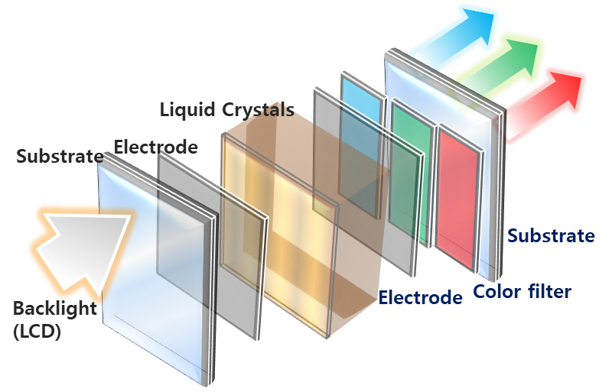
- 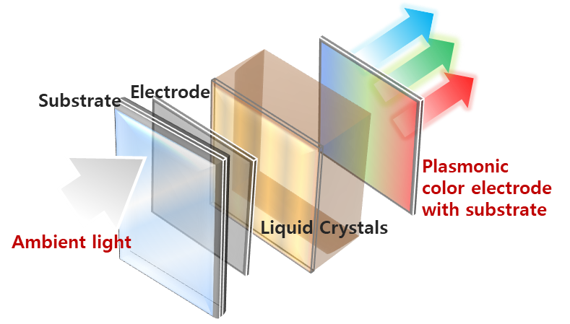

Fig. 1 Schematics of (a) the conventional device structure of liquid crystal displays (LCDs), and (b) the proposed structure including nano photonic based color materials (plasmonic color)

The technical convergence produced by nano technologies has spurred the development of novel transparent, flexible, stretchable, and other multi-functional devices. Among the many interesting features of nano structures, they have the remarkable ability to produce colors when they interfere with visible light. A nanostructure inspired by the components of a Morpho butterfly’s wing appears vivid blue without any colored ingredient.¹ Such structurally colored materials are being increasingly introduced as an alternative to conventional color technology.^{2,3} Unlike synthesized dyes or pigments⁴, a nano structure produces color based on simple design rules. In addition, structurally colored materials have higher stability when exposed to chemicals, heat or light than organic synthesized color materials.
For reproduce colors, surface plasmon enhanced metallic nano structure. We previously reported on plasmonoic color filters, including their design method and integration on realistic devices⁵; the fabrication method for large area applications⁶; and an MNA-based plasmonic filter integrated on transparent TFTs, which had the effect of improving the instability of TFTs under light⁷. In the same vein, the proposed structure in this work, the color electrode is consisted of an aluminum film which is perforated periodically with a circular holes.

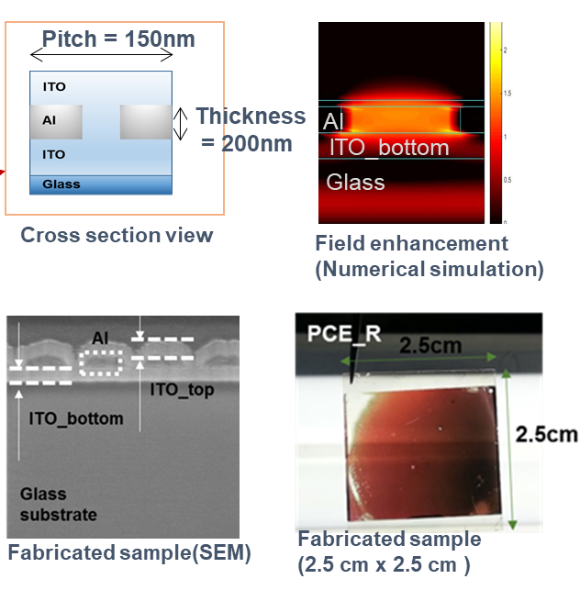

Fig. 2 The schematics of plasmonic color electrode with the thickness of 200 nm, the electric field enhancement around the nano hole, the cross section image of the fabricated color electrode obtained by SEM, and the photograph of the red electrode fabricated on to the area of 2.5 cm x 2.5 cm.

The finalized plasmonic color electrode structure has the height of within some hundreds nm. This thin and metal-based structure is advantageous for form-free devices such as flexible, stretchable, and etc.

III. Conclusion

In this work, a novel device structure for transparent display is suggested in which the electrode layer functions as filtering colors as well. Compared to the material based conventional color filter which has limitation in fabrication under submicron dimension (hard to pattern the color resist through the lithography), nano patterned pixel can be realized in more precise dimension. Therefore, the proposed electrodes in this work are not just for reducing device structure by combining two functions (coloring and electrode). Therefore, we expect this work will helpful to enhance the use of plasmonic structures in various fields

References

[1] Chung, K. et al. Flexible, angle-independent, structural color reflectors inspired by morpho butterfly wings. Adv. Mater. 24, 2375–9 (2012).
[2] Aguirre, C. I., Reguera, E. & Stein, A. Tunable Colors in Opals and Inverse Opal Photonic Crystals. Adv. Funct. Mater. 20, 2565–2578 (2010).
[3] Choi, H.-J. H. et al. Transmission-type photonic crystal structures for color filters. Opt. Express 21, 18317 (2013).
[4] Sabnis, R. W. Color filter technology for liquid crystal displays. Displays 20, 119–129 (1999).
[5] Do, Y. S. & Choi, K. C. Matching Surface Plasmon Modes in Symmetry-Broken Structures for Nanohole-Based Color Filter. IEEE Photonics Technol. Lett. 25, 2454–2457 (2013).
[6] Do, Y. S. et al. Plasmonic Color Filter and its Fabrication for Large-Area Applications. Adv. Opt. Mater. 1, 133–138 (2013).
[7] Chang, S. et al. Photo-Insensitive Amorphous Oxide Thin-Film Transistor Integrated with a Plasmonic Filter for Transparent Electronics. Adv. Funct. Mater. 24, 3482–3487 (2014).

